**Deploy DB to Azure VM**

Use the Deploy a SQL Server Database to a Windows Azure VM Wizard to deploy a database from an instance of the Database Engine to SQL Server in a Windows Azure Virtual Machine

**STEPS**:

1. Setup destination VM in Azure to have the ability to receive database transfer
   1. Deploy Azure VM using gallery with pre-built SQL Server 2014 CTP1 image

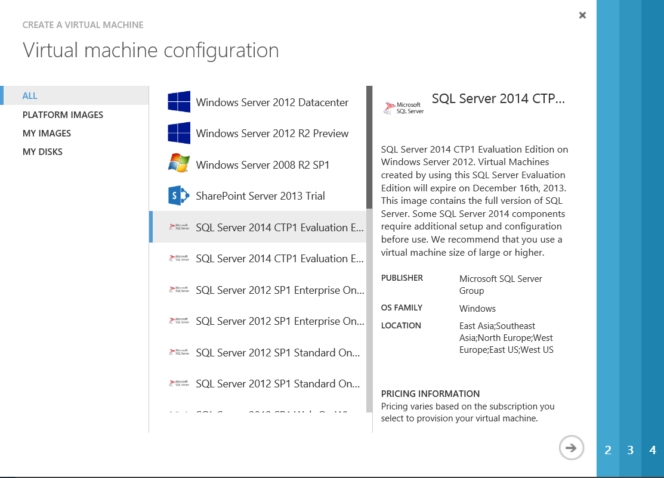

* 1. After VM is created, make sure **SQL Server Cloud Adapter** service is running

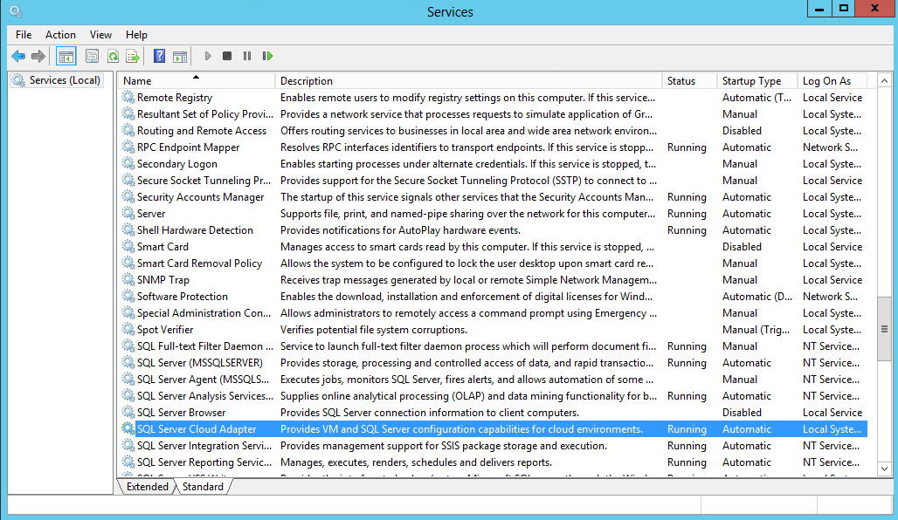

* 1. Create an endpoint of 11435 for the VM to allow SQL Server Cloud Adapter traffic using Azure Management Portal

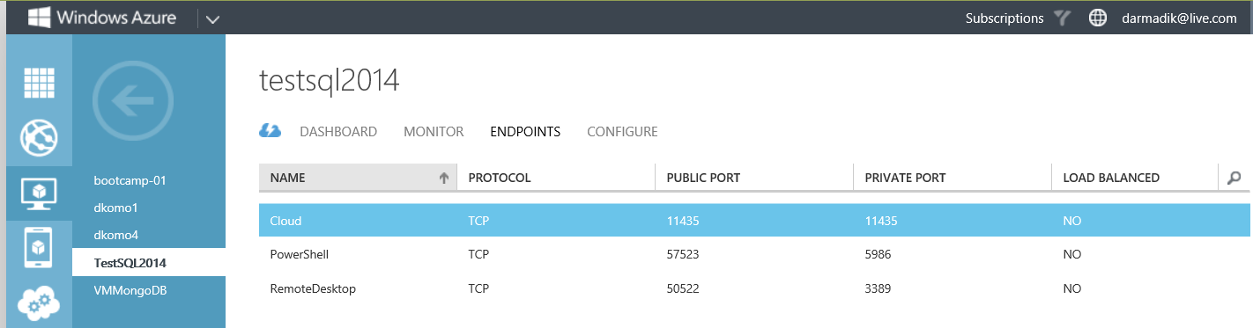

1. Deploy database from source SQL Server 2014 CTP1 server to the newly create Azure VM
   1. In the source server that runs SQL Server 2014 CTP1, launch **SQL Server Management Studio**, right click on the database to deploy, select **Tasks** and select **Deploy Database to a Windows Azure VM**

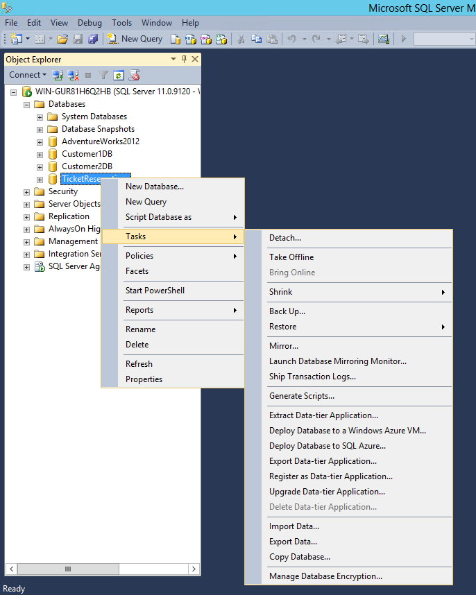

* 1. This will bring up Deploy Database to a Windows Azure VM wizard. The rest of the steps will walk through the wizard

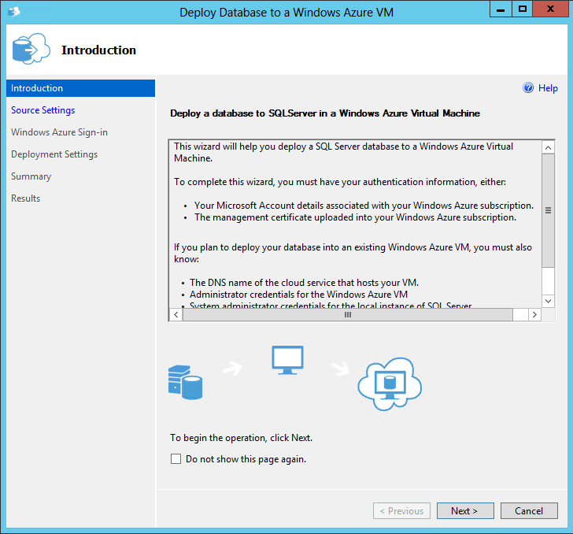

* 1. Click **Next** and Click **Connect** from **Source Settings** tab

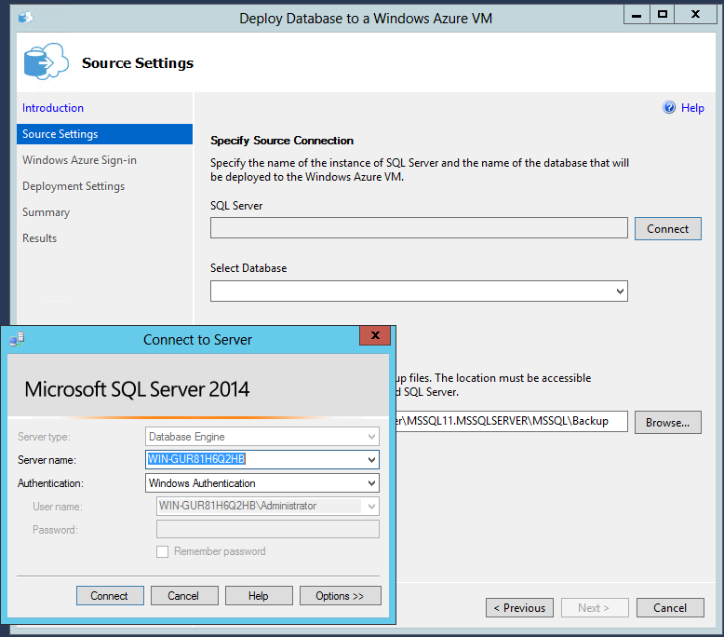

* 1. Enter the right credentials in the **Connect to Server** dialog box. Specify the right database to deploy under the **Select Database** drop-down box and click **Browse** to specify the backup location

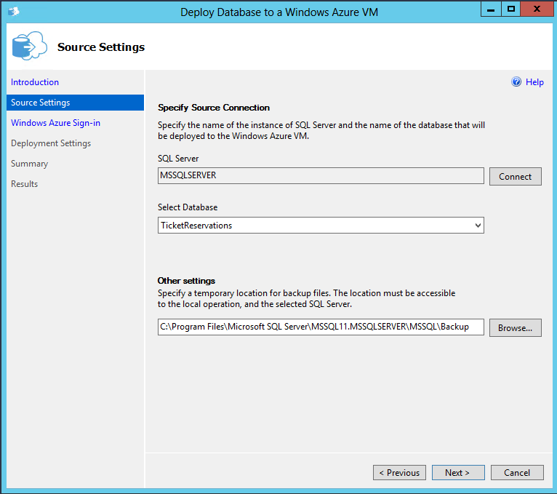

* 1. Click Next to advance to the Windows Azure Sign-in tab

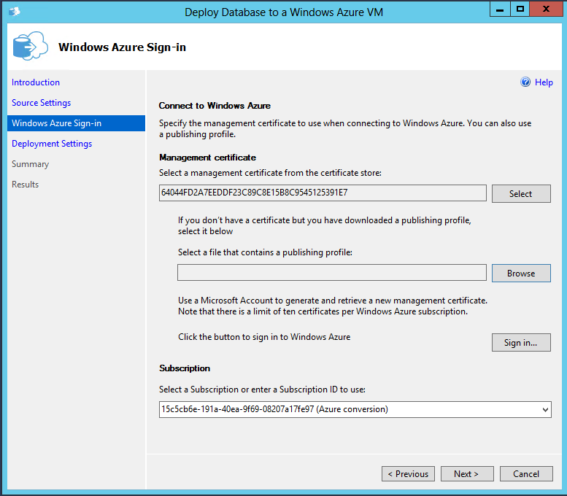

* 1. In the **Windows Azure Sign-in** tab shown above, click on **Sign-in** button to sign into your Azure account and download your Azure publishing profile.

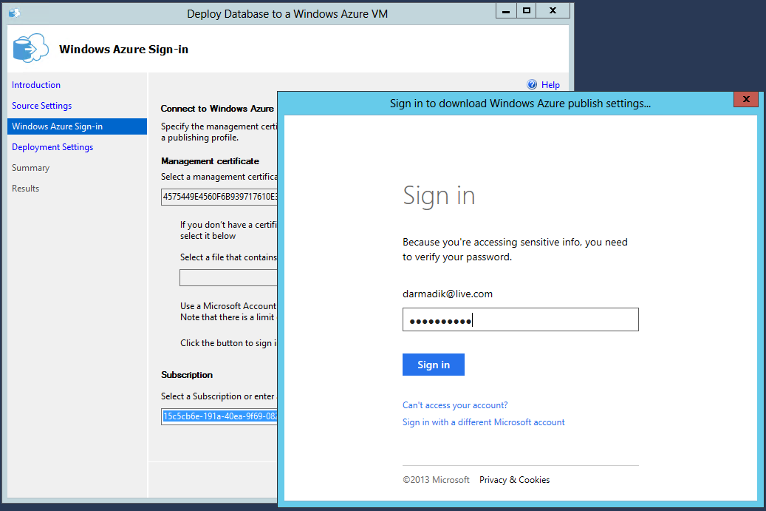

* 1. Select Yes to allow the wizard to access profile info and contact list

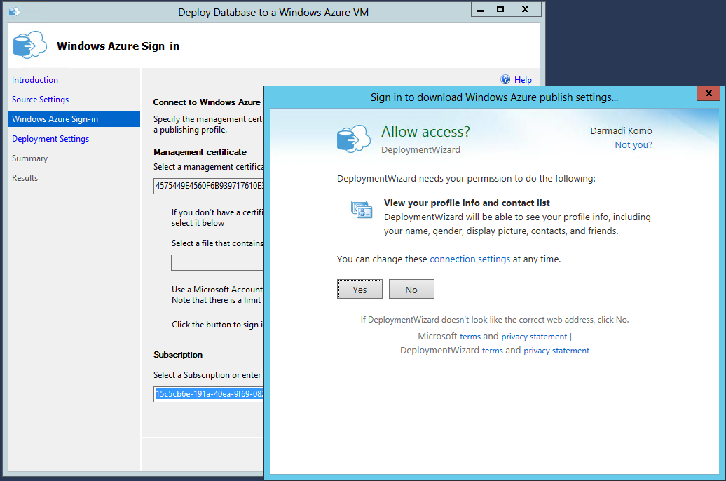

* 1. Your Azure publishing profile should be generated and you should be prompted to save the file. Just save the file to **Desktop**.

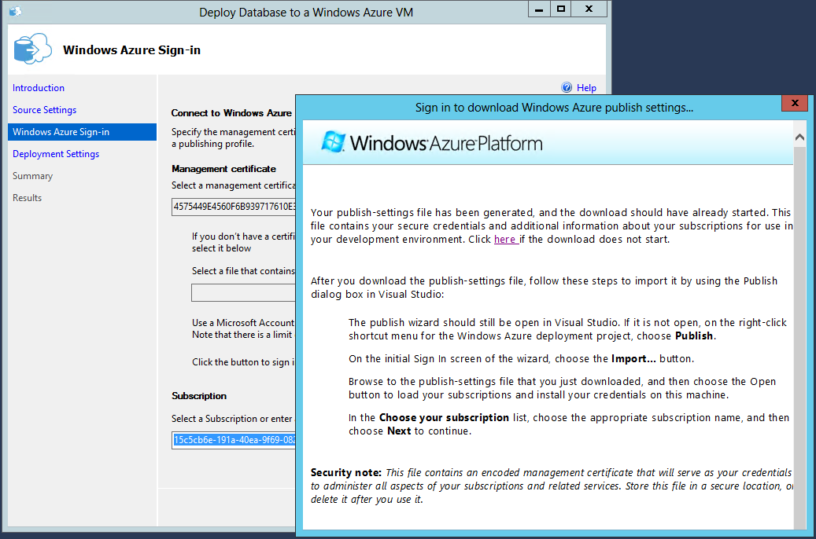

* 1. Back to the **Windows Azure Sign-in** tab, click on **Browse** button and select your Azure publishing profile that you saved in previous step
  2. Click **Next** to advance the **Deployment Settings tab**
  3. In the Deployment Settings tab, select the right Cloud Service name and Virtual Machine name that you have just created as the destination that contains SQL Server 2014 CTP1

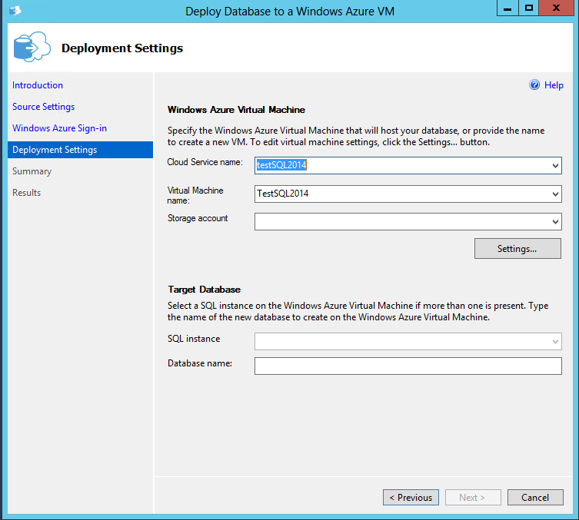

* 1. Click on **Settings** button to provide credential for Azure VM

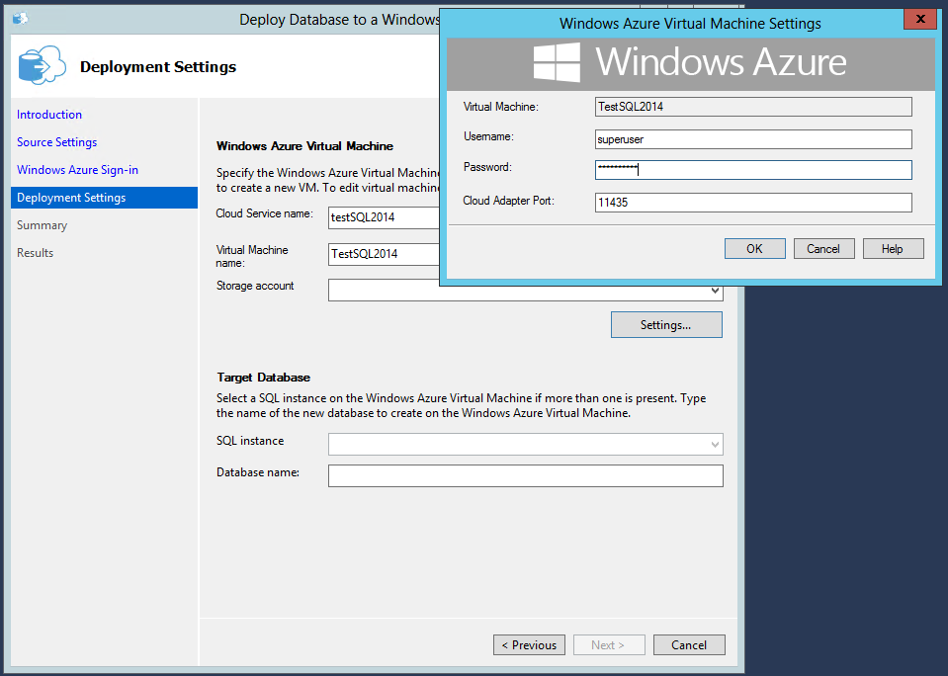

* 1. Make sure the target **SQL Server** instance and **Database name** are correct in the **Target Database** section

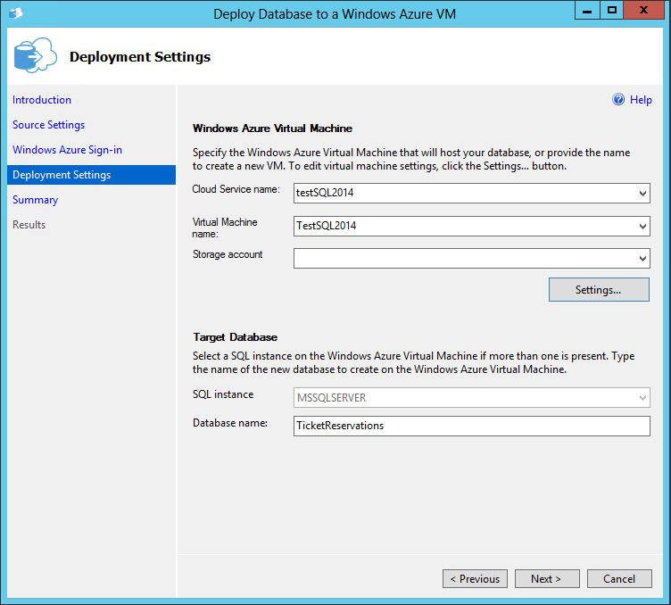

* 1. Click Next to advance to the Summary tab and click Finish to start deploying database

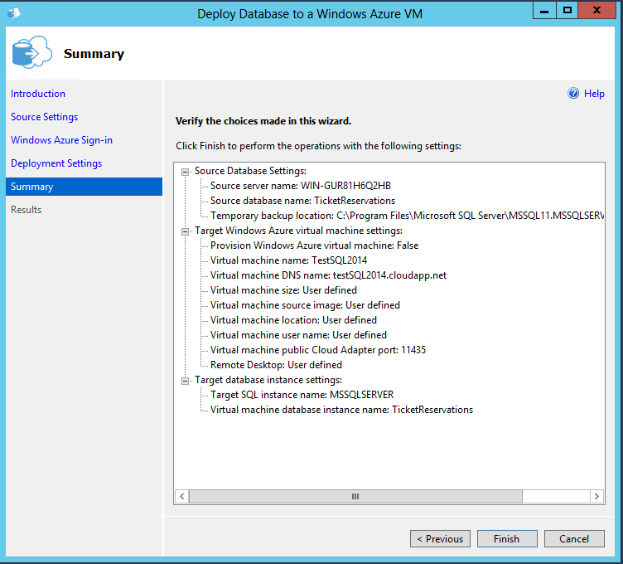

* 1. The database deployment will start with multiple steps

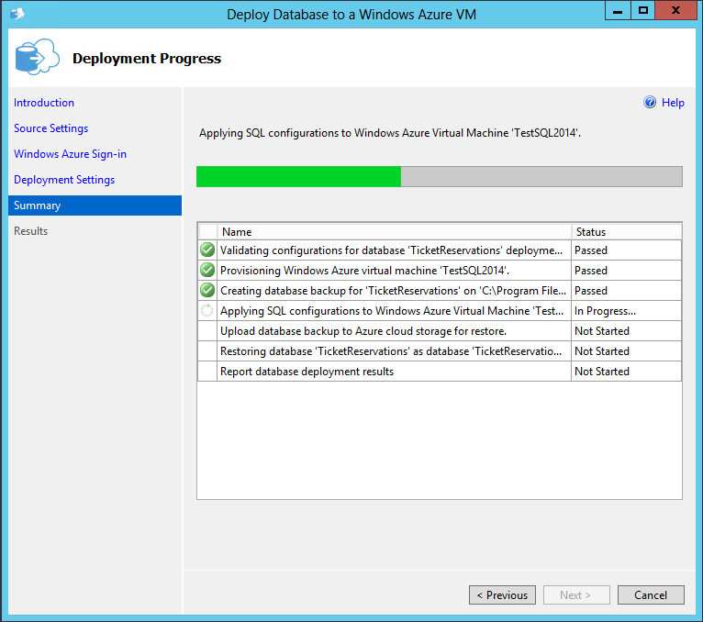

* 1. Once the deployment is done, you can verify the database is indeed being deployed to the Azure VM that you have just created. Congratulations on completing this demo!